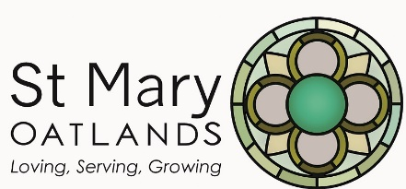

St Mary Oatlands, Oatlands Drive, Weybridge, KT13 9TS

LIVING A GENEROUS LIFE …. Leaving a Legacy!

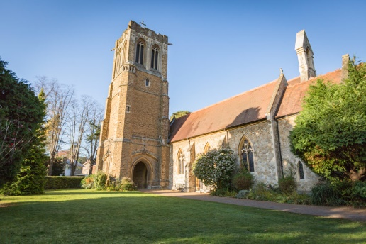

No one knows about that day or hour, not even the angels in heaven, nor the Son, but only the Father.
Matthew 24: 36.

These are the words of Jesus. Although he is speaking about His Second Coming, they could also be understood as a prediction about death. None of us knows the day or time when the trumpet shall sound, and God will call us home.

It is thus paramount that we set our affairs in order irrespective of our age or state of health. I want to encourage everyone in our church family, old and young, to make a will, review it regularly and consider leaving a gift to our church through your will.

Why does it matter?
It is a sound biblical principle to make a will "The good leave an inheritance to their children's children (Proverbs 13:22)."
Make sure you are prepared practically as well as spiritually. Whatever your age, write a will and keep it up to date.
Without a will, your loved ones could face much trouble, work, and expense after your death. Without a will, a court could decide how to distribute your assets and who should look after your children.
Many Christians give regularly and proportionately from their income. Why not provide proportionally from your estate too?
A gift in your will helps our church to live out our dreams and mission in our community.
It's a way to thank God for all the gifts of our lifetime and hand on undimmed the legacy we’ve received from past Christians (our building, our faith) to future generations.
Leaving a gift in your will is tax efficient and can reduce the inheritance tax you pay.

How to do it?
We strongly advise you to see an independent solicitor when writing or amending your will.
The Church of England has partnered with Farewill (winner of the National Will Writing Firm of the Year 2019, 2020 and 2021) to offer a free online will writing service. You can use Farewill in as little as thirty minutes and at no charge. Farewill are contactable on 020 8176 6753 or hello@farewill.com
The Church of England has a Church Legacy website at http://churchlegacy.org.uk, offering accessible and essential information for individuals who want to find out more about leaving a gift in their will.

Could this be you?
Here is a quote from a parishioner about why they have left a bequest in the will:
"I have included a gift to the church in my will because I love the idea of helping to preserve our church's future. I want to make sure my grandchildren's grandchildren can go to Sunday Juniors here."

Our Legacy Policy
St Mary’s welcomes gifts, however large or small, in wills and encourages members of our congregation and others having a positive interest in the parish to remember St Mary Oatlands in their bequests.
Such legacies should be made to promote Christ’s work so that there is a balance between the interests and aspirations of the donor and the ever-changing needs of our parish.

Suggested wording to leave a gift in your will
I give ……..% of my residual estate free of all taxes to the Parochial Church Council of the Parish of St Mary Oatlands, Weybridge (UK Registered Charity No. 1128836) in the Diocese of Guildford for its general purposes, and I declare that the receipt of an officer of the Parochial Church Council shall be a sufficient discharge to my executors and trustees.”

Three steps that we encourage every adult member of our parish family to take:

Make a will and review it regularly.
Please consider leaving a residuary gift in your will to the Parish Church of St Mary, Oatlands, Weybridge.
You can speak to any member of the Stewardship Team in our parish via the Parish Office. Email: parishoffice@oatlandschurch.org.uk
Telephone: 01932 231274

Think about it; pray about it; talk about it; find out more about it –
and then please act upon it!

Thank you
The Stewardship Team

